**Class Practice - 7**

**MIS 64038**

1. Explore the distribution of the **“carat”** variable in the diamonds dataset. What banwidth reveals the most interesting patterns?

As the carat increases the width does as well.

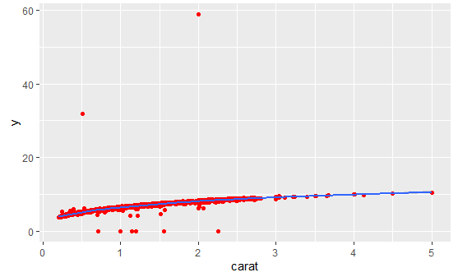

1. Explore the distribution of the **“price”** variable in the diamonds data. How does the distribution vary by cut?

Good, Very Good, and Premium seemed to demonstrate similar trends as far as the density of the distribution towards specific price points. Ideal seems to have the greatest skew.

